Thesis Proposal

By
Manuel Rodriguez Berdud
Graduate Student in Data Science

Spring 2026

Master of Science in Data Science
Florida Polytechnic University
Lakeland, Florida

Table of Contents:

- Abstract
- Literature Review
- Description of the work
- Project Timeline
- References

ABSTRACT

Could luck be defined as the meeting point between preparation and opportunity? This paper studies how randomness and institutional design influence performance and career outcomes in professional tennis, focusing on the “lucky loser” mechanism in Grand Slam tournaments. Lucky losers (LLs) are players who lose in the final round of qualifying but enter the main draw due to last-minute withdrawals, creating a quasi-random opportunity to compete at the highest level.
Using match-level and player-level data from Grand Slam events, the analysis will compare lucky losers with similar players who were eligible but not selected. The empirical strategy exploits the quasi-random nature of the selection process and uses a difference-in-differences (DiD) framework to estimate its causal impact on both short-term performance and long-term career outcomes. An event study approach will also be used to examine how effects evolve over time and to assess the validity of the identifying assumptions.
By combining institutional detail with causal inference methods, this research will contribute to the understanding of how unexpected opportunities affect performance and career development in competitive environments. The results provide insight into how small changes in access to elite competition can shape both immediate success and long-term trajectories in professional sports.

LITERATURE REVIEW

What does it look like to be a professional tennis player? How do these players get to the top of the rankings? What factors influence their career? These questions are easier to answer when we think of the top 100 players in the world. However, those who are fighting for a spot among the best need a stroke of good fortune to get where they want to be. Progression in professional tennis depends not only on individual skills but also on access to competitive opportunities. Grand Slams, the most important tournaments on the ATP and WTA tours, offer substantial ranking points, prize money, and media exposure, among other benefits. As a result, understanding how opportunities arise and how they shape outcomes is good for the study of success in professional tennis.
Previous research has examined the determinants of performance and career progression in tennis. One of these studies on career dynamics finds that players who achieve early success, such as strong performance in prestigious tournaments, are more likely to experience greater improvements in ranking and participation in elite competitions (Zappalà et al. 2024). Similarly, research on peak performance age suggests that tennis careers follow predictable life cycles, where early momentum can accelerate development and delay decline (Mlakar and Tušar, n.d.). Furthermore, studies on winner and loser effects demonstrate that short-term results can influence upcoming performance through momentum and strategy (Page & Coates 2017). This literature highlights that tennis careers are not pure reflections of ability, but rather dynamic processes influenced by prior outcomes.
Beyond performance dynamics, important research emphasizes the role of chance and path dependence in shaping success. The notion that small, often random events can have long-lasting consequences is well documented across competitive environments, including sports. For instance, studies such as The Paradox of Talent show that success in tennis tournaments is not determined just by skill, but also by stochastic elements such as draws and matchups (Zappalà et al. 2023). Similarly, research on early career setbacks and marginal wins suggests that minor differences in outcomes can produce divergent career paths over time (Maity et al. 2025). These findings are consistent with broader theories of path dependence, where initial conditions or random shocks can set individuals on trajectories that become increasingly difficult to alter (Lackner & Weichselbaumer, 2023). In the context of professional tennis, this implies that exogenous opportunities may significantly influence long-term success.
In addition to performance and randomness, the economic structure of professional tennis further amplifies the importance of opportunity. Tennis operates as a highly commercialized, media-driven sport in which player value is determined not only by performance but also by visibility and audience appeal. Research by a Spanish professor, Pedro Garcia-del-Barrio, demonstrates that players who generate greater media attention tend to capture disproportionate economic rewards, reflecting the role of broadcasting, sponsorship, and fan engagement in shaping financial outcomes (Garcia-del-Barrio & Pujol, 2015). This dynamic creates a “winner-take-most” environment, where access to the best tournaments significantly enhances a player’s earning potential and career prospects. Thus, as mentioned by David Felman in his paper Gender Competitiveness and Predictability, and Prize Money in Grand Slam Tennis Tournaments, participation in Grand Slam events is particularly valuable, as these tournaments offer the highest levels of exposure, prize money, and ranking points (Feldman et al., n.d.).
While the previous literature provides important insights into performance, randomness, and economic outcomes, less attention has been given to the institutional mechanisms that regulate access to elite tournaments. This gap is particularly relevant in the context of professional tennis, where entry into Grand Slam events is driven by a structured yet multifaceted system of rules and selection criteria. Incorporating an analysis of these mechanisms allows for a more comprehensive understanding of how players are granted entry, how opportunities are distributed across different stages of the tournament, and how formal regulations interact with elements of uncertainty. Ultimately, this perspective sheds light not only on who gets to compete at the highest level, but also on how institutional design can influence competitive dynamics and player outcomes.
Entry into Grand Slam events follows a structured system composed of three main pathways: direct acceptance based on ATP rankings (usually top 104 players), qualification through a multi-round qualifying tournament (around 16 qualifiers), and special entry mechanisms such as wild cards or protected ranking (the remaining spots). Players who do not meet the ranking threshold must compete in qualifying rounds, where only a limited number advance to the main draw. Those who lose in the final round of qualifying become eligible for selection as “lucky losers”, where a player withdraws from the main draw before the start of the competition. According to the International Tennis Federation (ITF) Grand Slam Rule Book, these replacements are selected from the pool of eligible players through a random draw, conditional on availability and timing of withdrawals.
This mechanism creates a unique institutional setting in which players with nearly identical performance in qualifying, having lost in the final round, may face substantially different opportunities due solely to chance. Existing research has highlighted the broader importance of tournament structure and entry rules in shaping competitive outcomes. For example, studies such as The Justice of the Grand Slam Tennis Tournaments emphasize how the draw design and entry mechanisms can influence fairness and performance distributions (Zimányi & Géczi, 2019). Other research points to the potential strategic and institutional dimensions affecting match outcomes and opportunities (Jetter & Walker, 2017).
In parallel, descriptive and journalistic papers suggest that entry into a Grand Slam main draw can be pivotal for lower-ranked players. Two of those articles document how even a single appearance in a Grand Slam can generate substantial financial rewards, ranking points, and visibility (Rothenberg, 2014) (Clarke, 2021). However, despite recognition of the importance of these mechanisms, there is limited empirical evidence on their causal impact. The random allocation of lucky loser spots can provide a good opportunity to study how exogenous access to elite competition affects long-term career outcomes.
This gap in the literature can be very beneficial given the broader emphasis on causal inference in related fields. In many observational settings, estimating the effect of an opportunity or intervention is complicated by selection bias, as individuals who receive the treatment may be different from those who do not. For example, studies in education and other domains often rely on advanced econometric techniques to isolate causal effects when randomization is not present (Koedinger et al. 2015). In contrast, the random selection of lucky losers in Grand Slam tournaments provides a natural experiment that mitigates these concerns. Because the assignment mechanism is exogenous, it allows for a cleaner comparison between players who receive the opportunity and those who do not, enabling more credible estimation of causal effects.
Building on these insights, this paper aims to contribute to the existing literature on tennis performance, the role of luck, and the economic value of tournament participation under Grand Slam mechanisms. Specifically, it investigates the causal impact of entering a Grand Slam main draw as a lucky loser on players’ future career outcomes. By leveraging the random selection process defined by the ITF rulebooks, this study provides a unique opportunity to examine how exogenous access to elite competition influences ranking trajectories, participation in future tournaments, earnings, and career longevity. In doing so, it contributes to a deeper understanding of how chance and opportunity interact with skill to shape success in professional sports.

DESCRIPTION OF WORK

- DATA & SOURCES
This study uses a combination of publicly available datasets that provide full information on professional tennis tournaments, including player characteristics and match outcomes.
The main data source comes from the collection of datasets compiled by Jeff Sackmann, which contains an open-access tennis repository with many ATP matches throughout the years (Sackmann, 2015 - 2026). His repository is often used in academic research as it contains player identifiers, rankings, match outcomes, and tournament progression.
In addition to this, more data is collected from official tennis websites, including the Association of Tennis Professionals (ATP) and the International Tennis Federation (ITF). These sources provide official and updated information about the players, including historical records that can be used to track player careers over time.
One of the most important sources to include in this study is the Grand Slam Rulebooks published by the ITF (Grand Slam Rulebook, 2026). These documents are essential for understanding the selection of lucky losers in Grand Slams, as well as the assignment mechanisms of these tournaments.
Our main units of observation in this study will be the eligible lucky losers in Grand Slam main draws, their “unlucky losers”, and the player rankings. Once we identify these units in the datasets, further variables will be considered for the analysis.
Thus, combining all these data sources will provide both tournament data and institutional context for a credible causal analysis.

- IDENTIFICATION STRATEGY
The identification strategy is based on a quasi-experimental research design that exploits the institutional rules governing the selection of lucky losers in Grand Slam tournaments.
How do Grand Slams choose these players?
- Players who lose in the final round of the qualifying competition can sign up for the lucky loser spot(s)
- A subset of these players becomes eligible for the random draw, based on the highest rankings
- When a player withdraws from the main draw, the four highest-ranked players are randomly drawn:
  - If there are more than two main draw withdrawals at the time the Qualifying competition is finished, then the size of the random draw will be the number of withdrawals plus two.
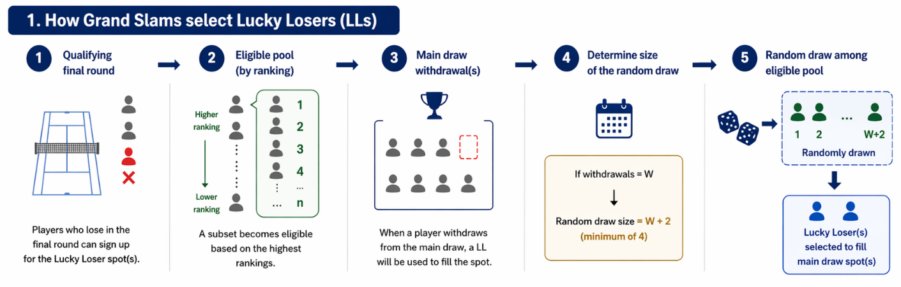
In case of confusion, Figure 1 visually represents how eligible players are selected as lucky losers.
Figure 1

Now that the lucky loser selection has been explained, we can define the experiment groups:
- Treatment Group (LL = 1):
  - Eligible player(s) selected as lucky loser(s) from the lottery
- Control Group (LL = 0):
  - Eligible player(s) not selected as lucky loser(s) from the lottery
This design ensures that both groups are similar in ranking, under the same conditions (both lost in the final round of qualifying when they were supposed to win), and subject to the same competitive environment. Figure 2 shows graphically how the two experimental groups are divided.
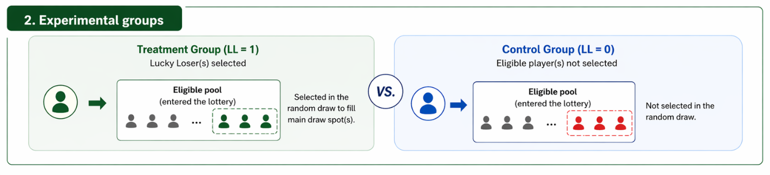
Figure 2
Key identification assumption: Conditional on eligibility, selection as a lucky loser is as if random.
We can assume this based on:
- Exogeneity of withdrawals:
  - Players withdraw from main draws typically due to injury or illness, so it is unrelated to the characteristics of eligible players
- No manipulation:
  - Conditional on losing in the final round of qualifying, players cannot influence their selection as Lucky Losers.
  - Moreover, players have no strategic incentive to deliberately enter the Lucky Loser pool.

Empirical Framework
The analysis will begin with a descriptive comparison of players selected as lucky losers and those who were eligible but not selected. Summary statistics and graphical analysis will be used to examine differences in pre-treatment characteristics and to visualize the evolution of outcomes over time. These descriptive patterns provide an initial assessment of comparability between groups and offer preliminary insights into potential treatment effects.
While descriptive analysis is informative, it does not allow for causal interpretation. To estimate the causal effect of lucky loser selection, the study adopts a difference-in-differences (DiD) framework:

$$Y_{it}=α_{i}+δ_{t}+β(LL_{i}×Post_{t})+ϵ_{it}$$
where $Y_{it}$ represents the outcome of interest for player $i$ at time $t$, $LL_{i}$ is an indicator for lucky loser selection, and $Post_{t}$ denotes the post-treatment period. The model includes player fixed effects ($α_{i}$) and time fixed effects ($δ_{t}$).
This approach combines:
- Before vs. after comparisons, capturing changes in outcomes over time
- Treated vs. control comparisons, contrasting lucky losers with non-selected eligible players
The coefficient $β$ measures the difference in outcome changes between the two groups and captures the causal effect of lucky loser selection.
The validity of this approach relies on the parallel trend assumption, which requires that, in the absence of treatment, both groups would have followed similar outcome trajectories. Given the institutional setting and the comparability of players within the eligible pool, this assumption is valid in this context.

- OUTCOMES
Our analysis will mainly focus on medium and long-term career outcomes in order to capture the persistent effects of lucky loser selection. As of right now, these are some of the outcome variables that could be studied:
- Ranking Trajectory
  - Looking at different stages (after 6 months, after a year…)
- Future Performance
  - Matches won in the rest of that season
  - Win rate over the following season
- Tournament Participation
  - Number of high-level tournaments played
  - Probability of direct qualification into Grand Slams
    - Due to ranking, Lucky Loser, or Wild Card
- Financial Outcomes
  - Prize money earned in future periods
By focusing on outcomes measured after treatment, the analysis isolates persistent career effects rather than short-term gains.

- EMPIRICAL METHODS
The empirical analysis combines descriptive and causal approaches to study the impact of lucky loser selection. Descriptive statistics and graphical analysis are used to assess comparability and illustrate outcome trajectories. The main causal framework is based on a difference-in-differences design, which exploits variation over time between treated and control players. Additionally, event study methods may be used to explore the dynamic evolution of treatment effects and assess the validity of the identification assumptions.

PROJECT TIMELINE

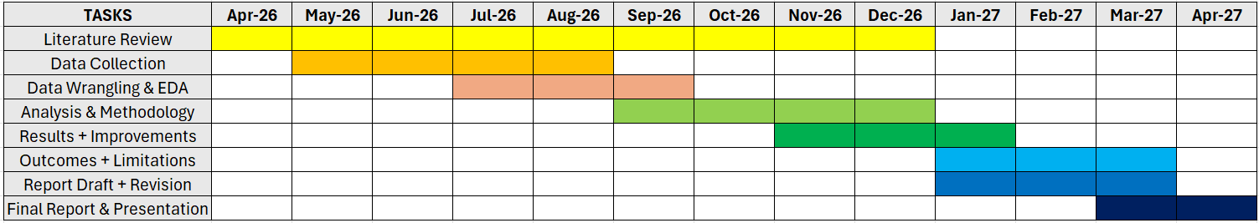
The following Gantt Chart highlights the expected timeline for each task:

Note that this is an approximation of how much time to dedicate to each task so that time is managed appropriately. Researching related work will take the longest, as comparing studies can help in the enrichment of this paper. Also, collecting and manipulating the data will be important to shape our goals before modeling.

REFERENCES

“2026 Grand Slam Rule Book.” n.d.
ATP Tour. n.d. “Official Site of Men’s Professional Tennis | ATP Tour | Tennis.” Accessed April 15, 2026. http://www.atptour.com/en.
Clarke, Liz. 2021. On Tennis’s Lower Rungs, Landing a Spot in Main Draw of a Grand Slam Can Help Sustain a Season.
Feldman, David, Shulamith T. Gross, and Yang Long. n.d. GENDER COMPETITIVENESS AND PREDICTABILITY, AND PRIZE MONEY IN GRAND SLAM TENNIS TOURNAMENTS.
Garcia-del-Barrio, Pedro, and Francesc Pujol. 2015. “Sport Talent, Media Value and Equal Prize Policies in Tennis.” In The Economics of Competitive Sports, edited by Plácido Rodríguez, Stefan Késenne, and Ruud Koning. Edward Elgar Publishing. https://doi.org/10.4337/9781783474769.00015.
“Grand Slam Tennis Tournaments | ITF.” n.d. Accessed April 15, 2026. https://www.itftennis.com/en/itf-tours/grand-slam-tournaments/.
Jetter, Michael, and Jay K. Walker. 2017. “Good Girl, Bad Boy? Evidence Consistent with Collusion in Professional Tennis: Good Girl, Bad Boy?” Southern Economic Journal 84 (1): 155–80. https://doi.org/10.1002/soej.12213.
Koedinger, Kenneth R., Jihee Kim, Julianna Zhuxin Jia, Elizabeth A. McLaughlin, and Norman L. Bier. 2015. “Learning Is Not a Spectator Sport: Doing Is Better than Watching for Learning from a MOOC.” Proceedings of the Second (2015) ACM Conference on Learning @ Scale, March 14, 111–20. https://doi.org/10.1145/2724660.2724681.
Lackner, Mario, and Michael Weichselbaumer. 2023. “Can Barely Winning Lead to Losing? Gender and Past Performance.” Journal of Economic Behavior & Organization 208 (April): 258–74. https://doi.org/10.1016/j.jebo.2023.02.018.
Maity, Suman Kalyan, Yang Wang, Nima Dehmamy, Victoria Medvec, Brian Uzzi, and Dashun Wang. 2025. “Early Career Setback and Future Achievement in Professional Sports.” Scientific Reports 15 (1): 33505. https://doi.org/10.1038/s41598-025-17271-z.
“Microsoft Word - Grand Slam Rulebook 2026-F.” n.d. Accessed April 14, 2026. https://www.itftennis.com/media/5986/grand-slam-rulebook-2026-f2.pdf.
Mlakar, Miha, and Tea Tušar. n.d. Analyzing and Predicting Peak Performance Age of Professional Tennis Players.
Page, Lionel, and John Coates. 2017. “Winner and Loser Effects in Human Competitions. Evidence from Equally Matched Tennis Players.” Evolution and Human Behavior 38 (4): 530–35. https://doi.org/10.1016/j.evolhumbehav.2017.02.003.
Rothenberg, Ben. 2014. In Wimbledon Lottery, Lucky Losers Win a Second Chance.
Sackmann, Jeff. (2015) 2026. JeffSackmann/Tennis_atp. March 13, released April 12. https://github.com/JeffSackmann/tennis_atp.
Zappalà, Chiara, Alessio Emanuele Biondo, Alessandro Pluchino, and Andrea Rapisarda. 2023. “The Paradox of Talent: How Chance Affects Success in Tennis Tournaments.” Chaos, Solitons & Fractals 176 (November): 114088. https://doi.org/10.1016/j.chaos.2023.114088.
Zappalà, Chiara, Sandro Sousa, Tiago Cunha, Alessandro Pluchino, Andrea Rapisarda, and Roberta Sinatra. 2024. “Early Career Wins and Tournament Prestige Characterize Tennis Players’ Trajectories.” EPJ Data Science 13 (1): 32. https://doi.org/10.1140/epjds/s13688-024-00472-3.
Zimányi, Róbert G., and Gábor Géczi. 2019. “The Justice of the Grand Slam Tennis Tournaments on the Basis of Draw, Competition Format System and Final Result: A Case Study of the US Open 2017 Men’s Singles Tournament.” Physical Culture and Sport. Studies and Research 83 (1): 26–38. https://doi.org/10.2478/pcssr-2019-0018.

Association of Tennis Professionals
Women Tennis Association

